**UNHM MATH 422 Exam #1** NAME______________________________________________

**SPRING 2023**  Date_____________________________________

**PLEASE REMEMBER:**  Show your reasoning and/or math work in every problem. Some questions have more than one part. Make sure you answer every part of the question that was asked. You are being asked to calculate some things and interpret others.

***Base Score (52 points)***: Did you *attempt* to answer every question? YES NO

**1. (4 pts)**

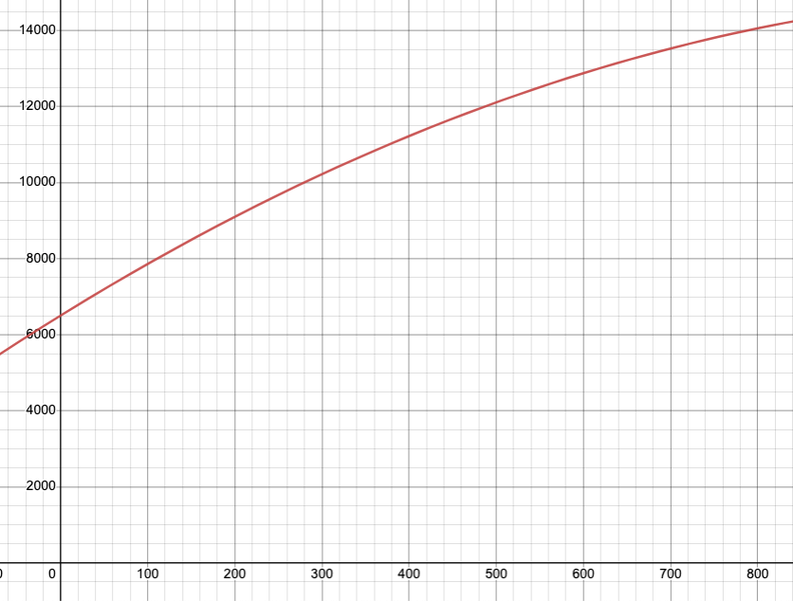The total cost *C(q)*, in dollars, to produce *q* items is given by the function graphed below.

Cost (C)

Quantity (q)

Find the average cost per item (the average rate of change) when increasing production from **240 units** to **700 units**.

Show your work here:

UNHM MATH 422 Exam #1 Page 2/7 Initials_____________

**2. (4 pts)**

You have estimated the cost function for producing items will be , and expect to bring in $43.64 in revenue for each item sold. Assume you are selling as many items as you are producing. . Cost and revenue are shown here:

a) Find the cost of producing 300 items.  
  
b) How many items can be produced with a budget of $50,400?  
  
c) How many items need to be produced to break even?

d) How much revenue comes from producing 800 items?  
  
Show your work here:

UNHM MATH 422 Exam #1 Page 3/7 Initials______________

**3. (4 pts)**

The value of business furniture is assumed to depreciate (decrease) in value linearly.  The value was $44,000 in 2012 and $37,100 in 2015. Let x = 0 be the year 2000.

a) Find an equation for the value of the furniture (y = mx+b).  Be sure to state what each variable represents (x and y).

b) In what year will the value drop below $20,000?  Use your equation or use a table.

c) What was the value of the furniture when it was purchased in 2000?

Show your work here:

UNHM MATH 422 Exam #1 Page 4/7 Initials______________

**4. (4 pts)**

Suppose quantity (*q*) of a product when the price is *p* dollars is given by the demand equation   , and the supply equation  . You are asked to graph these two equations. Create two tables of (*q, p*) values and plot them here.

*p*

*q*

a) Sketch the supply and demand curves

b) Find the equilibrium price and quantity.

Show your work here:

UNHM MATH 422 Exam #1 Page 5/7 Initials______________

**5. (4 pts) Multiple Choice – Circle the best option**

Bob just retired and wants to move his $600,000 retirement into safer investments.  He has found a very safe municipal bond fund paying 3% interest, and riskier corporate bond fund paying 5% interest.  He wants to invest as ***little as possible*** in the riskier account but needs to earn $23,640 per year to live on.

If x is the amount invested in the less risky account, which of the following will give him the income he needs?

1. He’ll need to invest the full amount ($600,000) in the riskier fund
2. Bob can invest $318,000 in the less risky account and $282,000 in the riskier account
3. Bob should invest $282,000 in the less risky account and $318,000 in the riskier account
4. Bob can invest the full amount ($600,000) in the less risky fund

**6. (4 pts)**

A regression was run to determine if there is a relationship between hours of TV watched per day (*x*) and the number of sit-ups a person can do (*y*).  The results were:

The relationship between sit-ups and hours is in the form of y = mx+b  
slope (m) = -0.79  
y-intercept (b) = 23.85  
r2 = 0.4887 (indicates the strength of the relationship)  
r = -0.6991

1. If a person watches 19 hours of television a day, predict how many sit-ups he can do.
2. If a person can do 9 sit ups, predict how many hours of television a day they watch.  
     
    hours

UNHM MATH 422 Exam #1 Page 6/7 Initials______________

**7. (4 pts) Multiple Choice**

Given a function and what is the **range** of f ?



**8. (4 pts)**

Based on the table below,

|  |  |  |  |  |  |  |  |  |  |  |
| --- | --- | --- | --- | --- | --- | --- | --- | --- | --- | --- |
|  | 0 | 1 | 2 | 3 | 4 | 5 | 6 | 7 | 8 | 9 |
|  | 57 | 28 | 86 | 4 | 25 | 93 | 71 | 5 | 48 | 56 |

a. Evaluate ---------> =   
  
b. Solve =

**9. (4 pts)**

When , evaluate   
  
  

**10. (4 pts)**

Find the slope of the line between the points .  
  
The slope is:

UNHM MATH 422 Exam #1 Page 7/7 Initials_____________

**11. (4 pts)**

Determine the domain and range of the following graph:

**12. (4 pts)**

Name the interval(s) on which the following is **decreasing**: (Note there may only be one interval, or more than one)

The function is **decreasing** on what x

interval(s)?

**Exam Scoring Sheet**

Base Score – Did you attempt EVERY question? _______________ (52 points possible)

Question #1 ______________ (4 points possible)

Question #2 ______________ (4 points possible)

Question #3 ______________ (4 points possible)

Question #4 ______________ (4 points possible)

Question #5 ______________ (4 points possible)

Question #6 ______________ (4 points possible)

Question #7 ______________ (4 points possible)

Question #8 ______________ (4 points possible)

Question #9 ______________ (4 points possible)

Question #10 ______________ (4 points possible)

Question #11 ______________ (4 points possible)

Question #12 ______________ (4 points possible)

TOTAL: _______________

+++++++++++++++

**Key - Form 1**

1. C(200) = 11000, C(700) = 14000. $6 per item
2. a) C(300) = 35,700  
   b) . q = 2500  
   c) . q = 3466.67
3. = 2300, giving the equation , where V is the value t years after 2012. Solving gives t = 10.43, so the value will be $20,000 in year 2022
4. 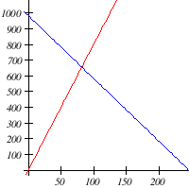

* Solving gives the equilibrium quantity of 82 at a price of $656

1. Letting be the amount invested in municipal bonds, and the amount invested in corporate bonds:  
    .  
     
   If you were to solve this, the answer is m = $318000, c = $282000
2. 9 ~ 18.8

License info at: <https://www.myopenmath.com/course/showlicense.php?id=98404-98405-98406-98407-98409-98383-98368>